Stephen Re – Assignment 11

1. A screenshot of a computer screen

   Description automatically generated
2. A screenshot of a computer

   Description automatically generated
3. A screenshot of a computer

   Description automatically generated

4a,b,c,d and 5

I got frustrated trying to use the template provided. The instructions didn’t make any sense and I was struggling with it, so I did it slightly differently than I think it was meant to be done. I fully commented the code so you can follow along. The result was the same. Each time you click on the ‘Buy’ button or changed the bookId in the url, the book would be added to the shopping cart.

In case you absolutely need the screenshots asked for in the instructions, here are the ones that are closest to the ones asked for.

4a

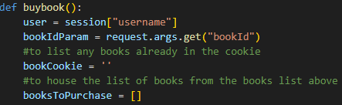

4b

4c

4d

5: full commented code and web page output

